MARGIT FUSSI (Liedbegleitung)
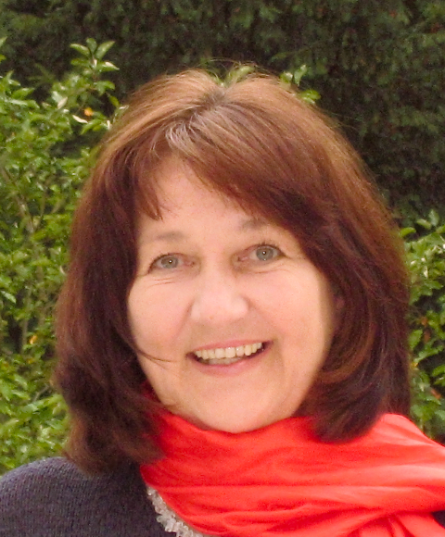
She performs as a piano soloist, as an accompanist for singers and instrumentalists (Hans Hotter, Kim Borg, Iliana Cotrubas, Robert Holl, Elly Ameling, Kurt Equiluz, Graziella Sciutti et al.), as well as and organist and harpsichordist. She has been the accompanist for master classes in Vienna, Heidelberg, Stuttgart, Berlin, Aldeborough, Matsue, Osaka, Nagoya, Cleveland. She has been a teacher for Lied-accompanist in Tokyo, Matsue, Hamamatsu as well as in Seoul and at the Vienna Master Classes. She can be credited with many CD and radio recordings.

